- Discount Reason picklist field configuration and page layout placement
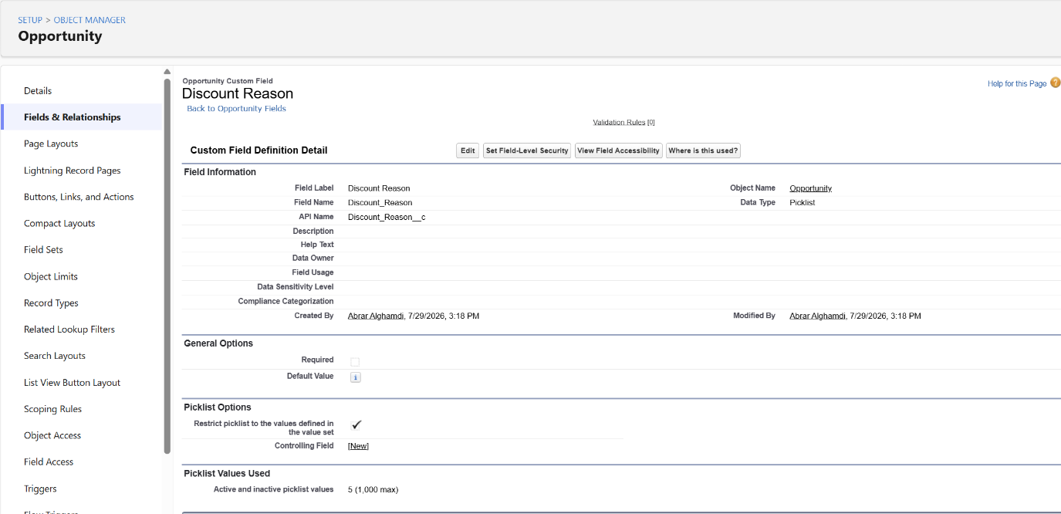
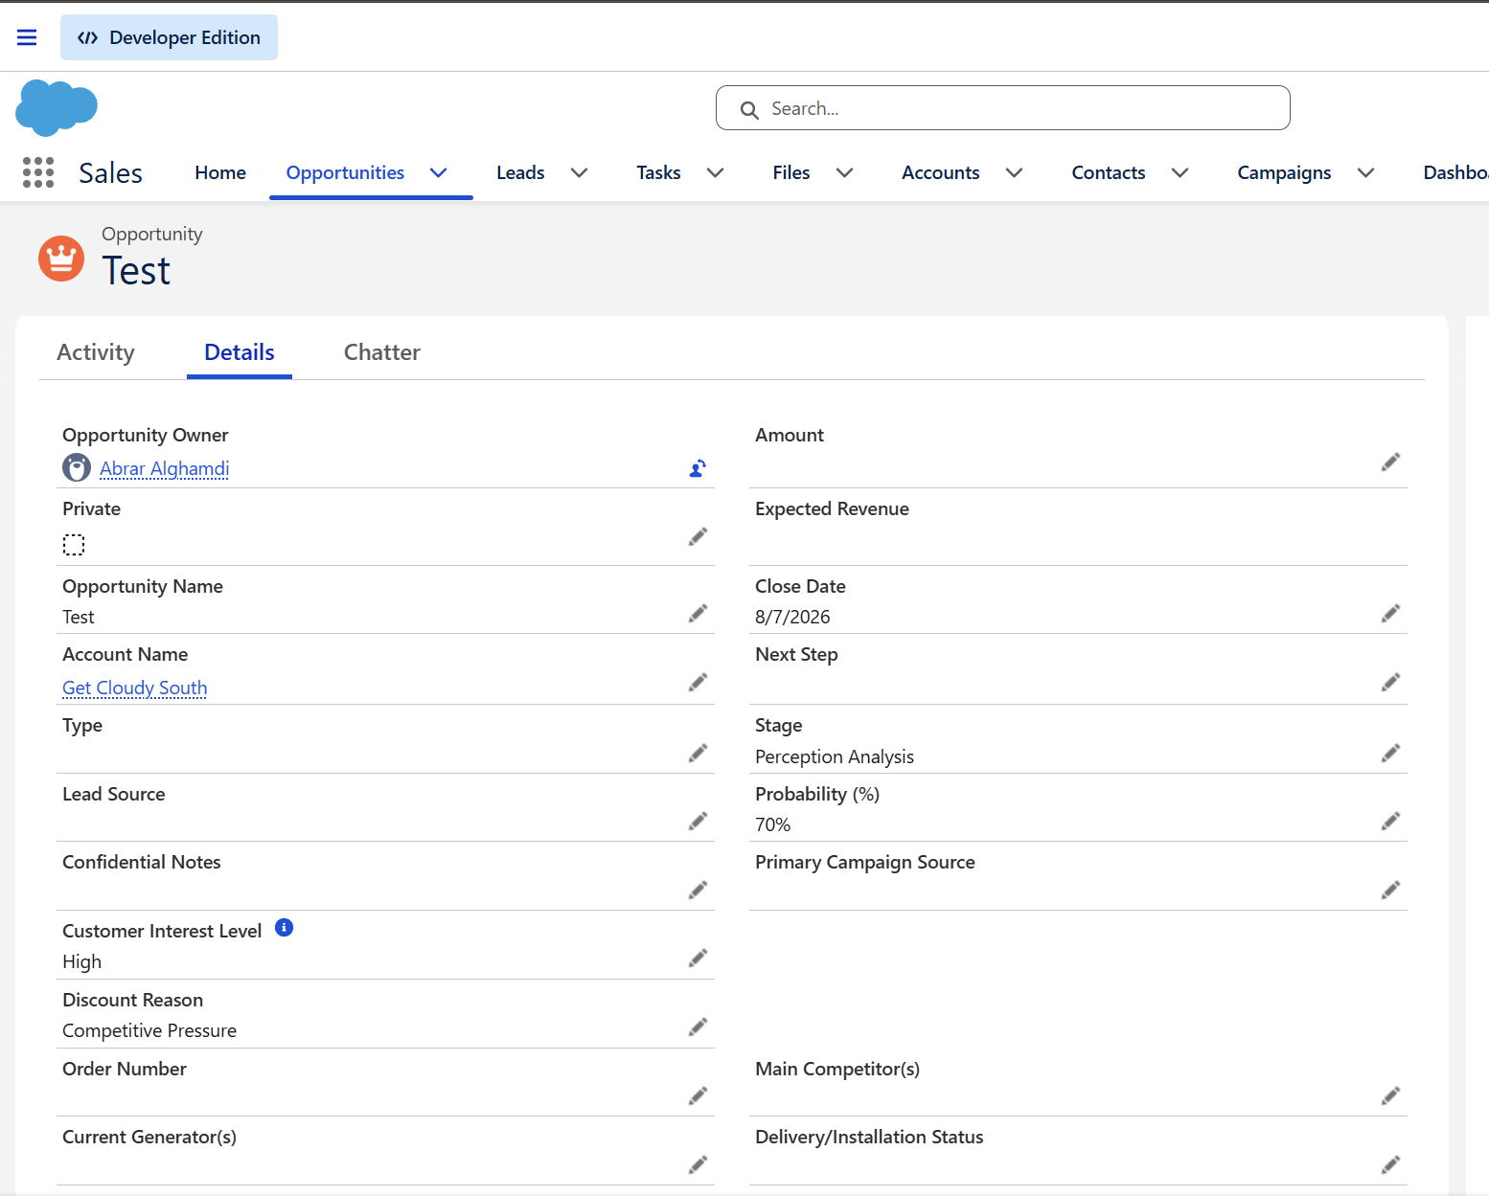

- pipeline by Stage report showing grouped data with Stage and Amount summary
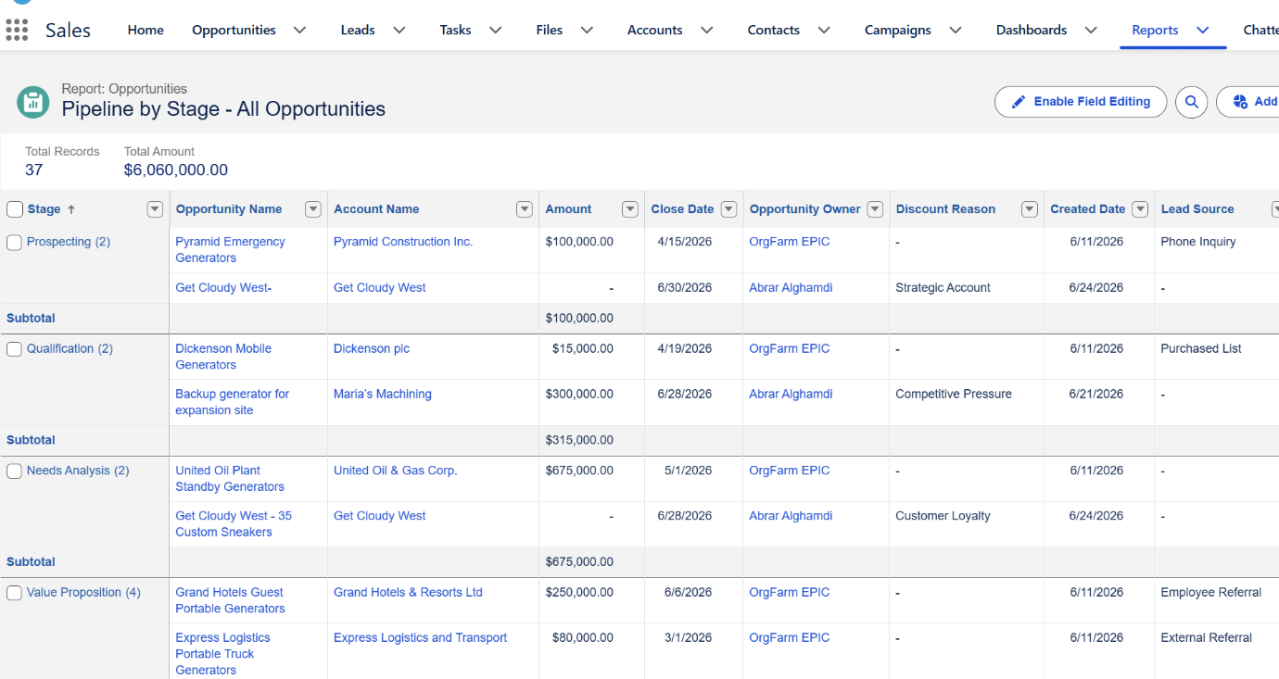

- Top Opportunities by Amount report
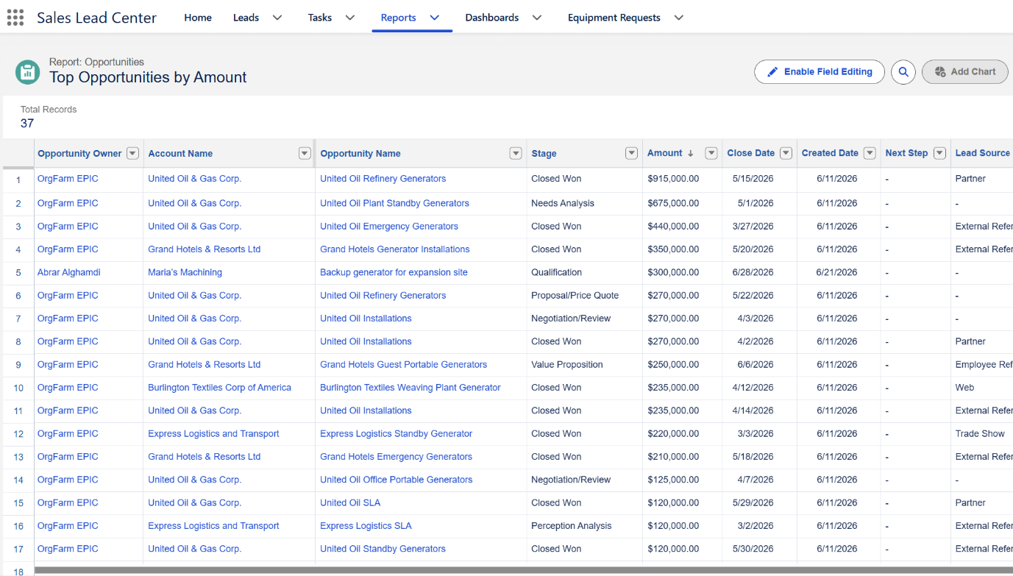

- Opportunities by Owner and Stage report
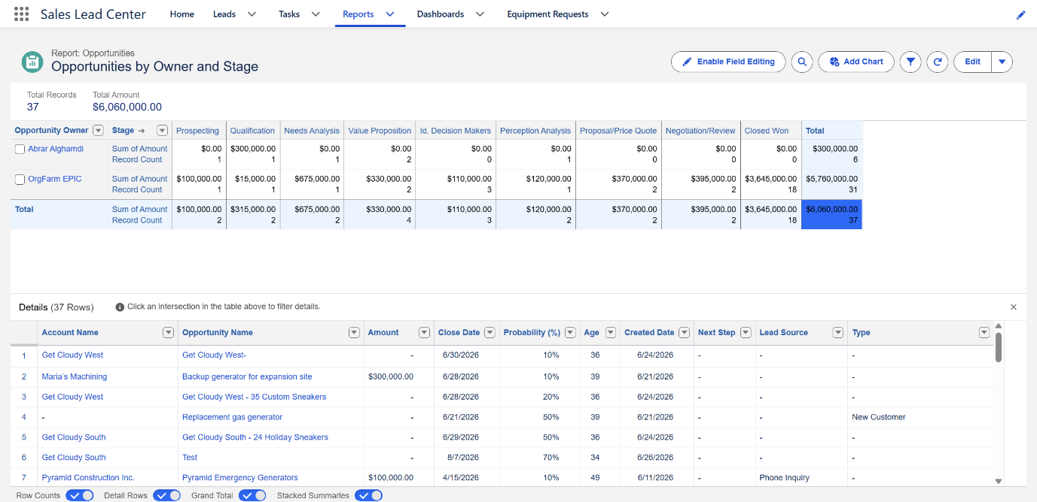

- Close Date Trends report showing at least 2–3 months of data
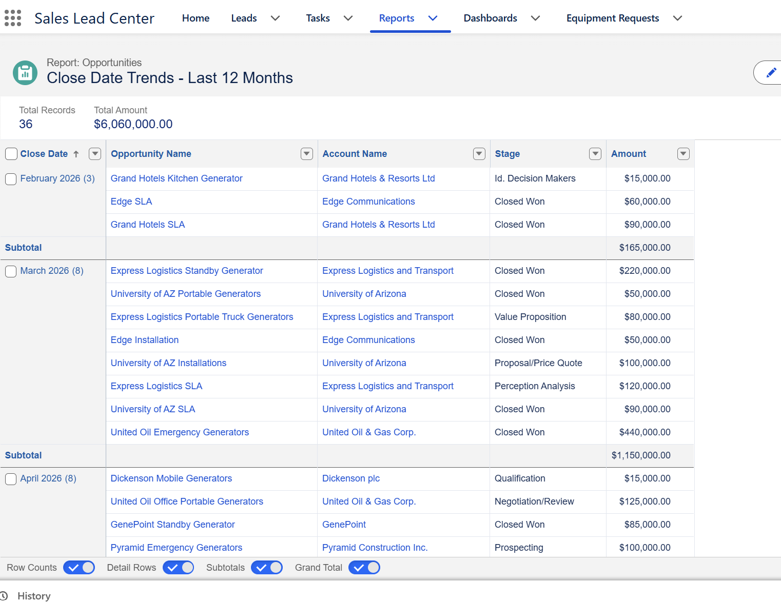

- Sales Leadership Dashboard with all four components visible and populated
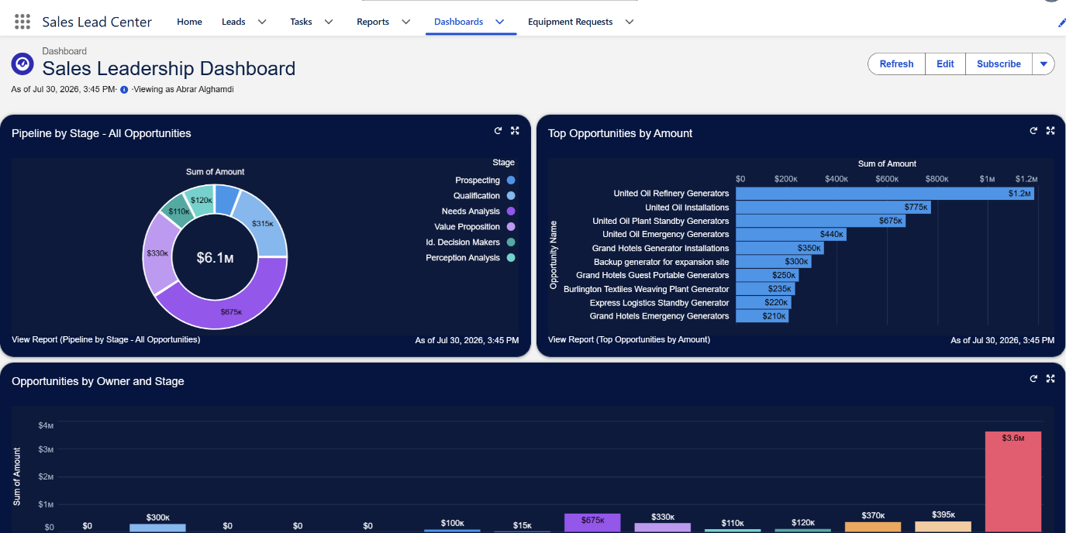
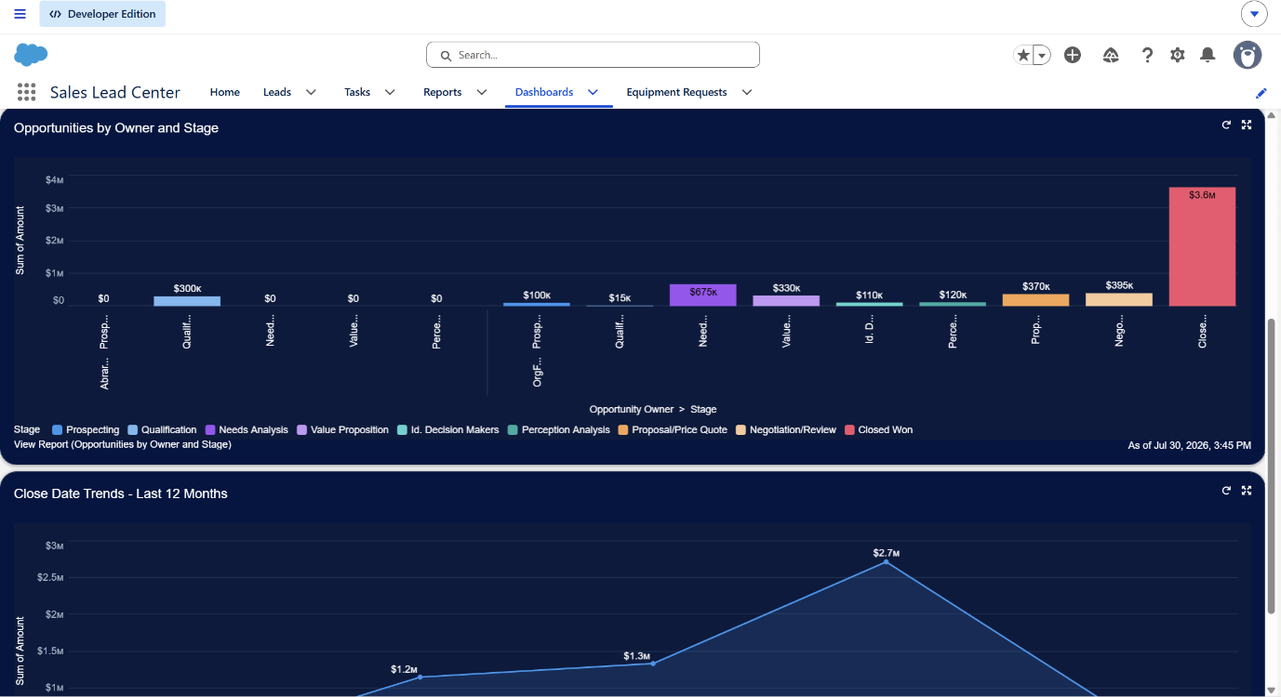
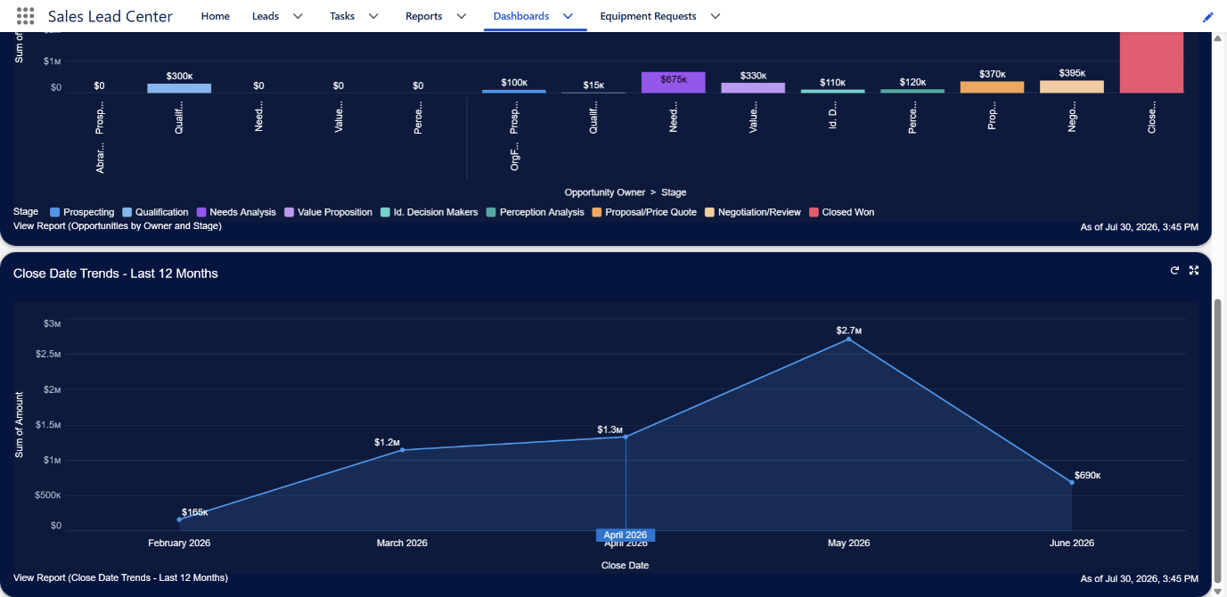

7.Approval process configuration showing entry criteria and approver settings
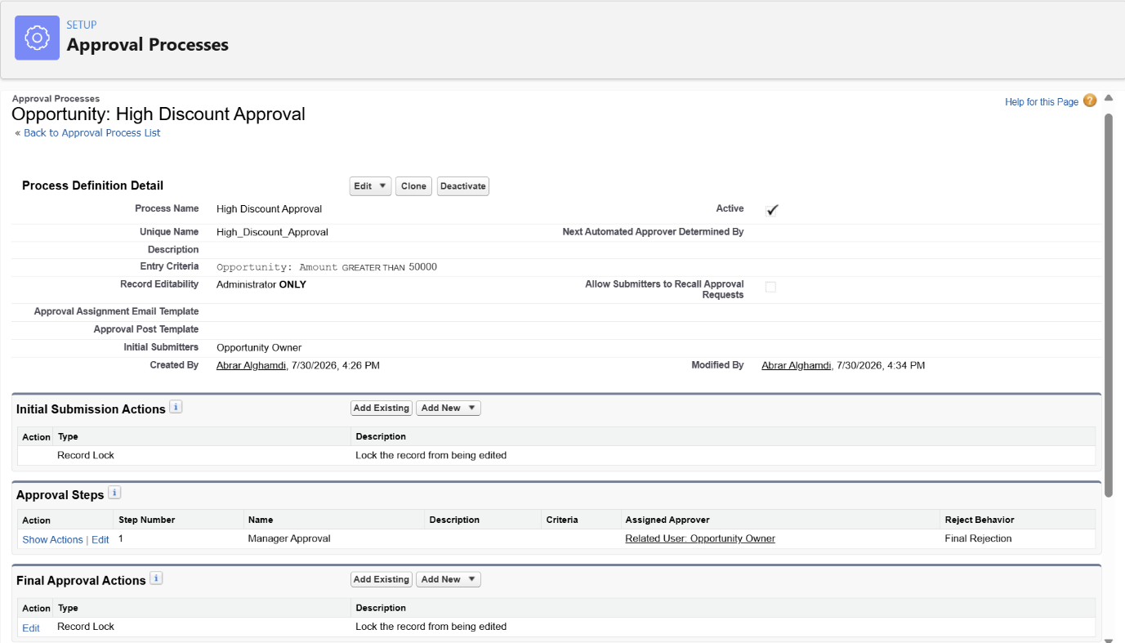

8. An Opportunity record in Pending Approval status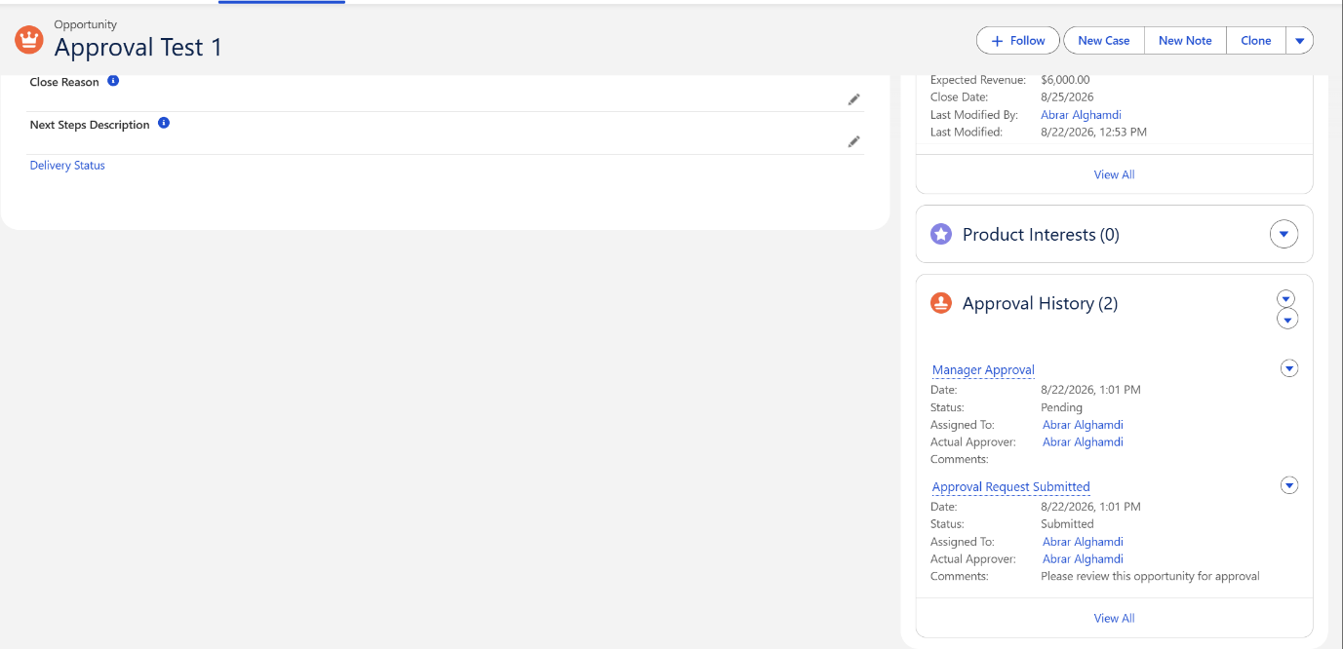

9. The completed approval showing the final status (one Approved, one Rejected)
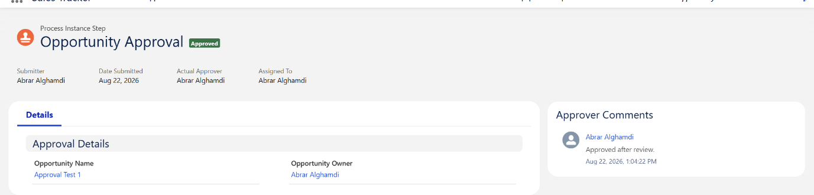
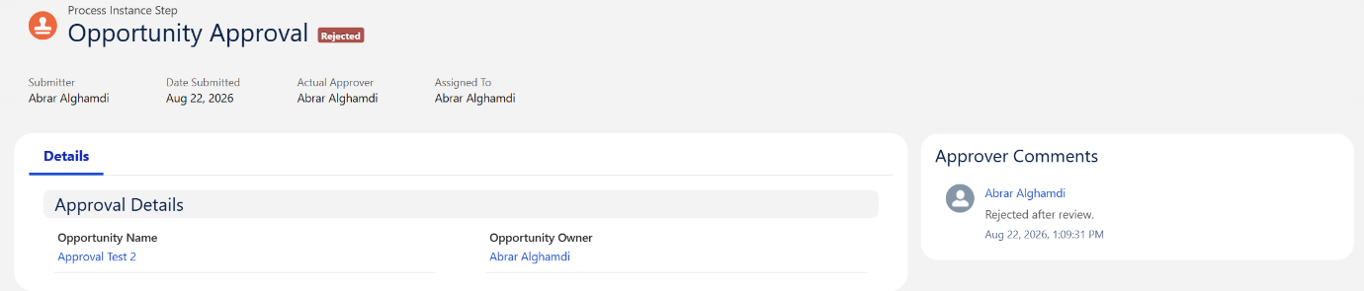

10. The refreshed dashboard reflecting the newly created test Opportunities from Part 5
